Relative Photometry of Stars in the Orion Nebula with the Pima Community College 12” Mead Telescope

Sarah C. Hagen and Patrick McGuire
Pima Community College Downtown Campus, Tucson, AZ
And Steward Observatory, University of Arizona, Tucson, AZ
shagen@azstarnet.com
mcguire@as.arizona.edu

On December 16, 1998 we took images using Pima Community College’s 12 inch Mead telescope and a CCD Electrim camera (from the University of Arizona) of several objects in the sky, including the binary star  Andromeda, Saturn and several of its moons, and the Orion Nebula. The most fascinating was the Orion Nebula (M42) due to its size and structure. After processing the images on the computer our next task was to determine exactly which stars in the nebula we photographed. We finally concluded the brightest of the stars we photographed were in the Trapezium of the Orion Nebula.
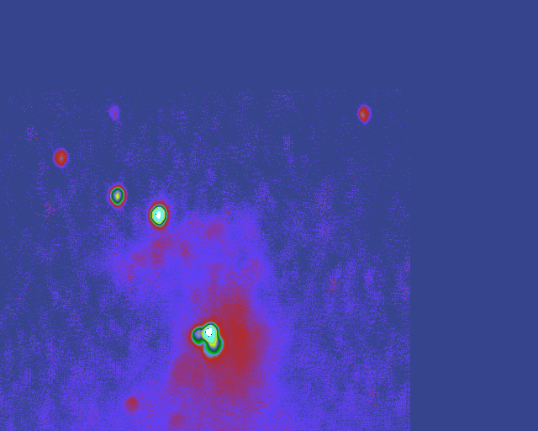
First, we co-added one-hundred one-second images of the nebula using an IDL computer script at the University of Arizona. This was necessary because the tracking of the telescope was rather poor, with approximately 5 arcseconds of image jitter over a few seconds of observation. We chose one of the medium- brightness stars as a reference, and shifted all the images so the star’s brightest pixel was fixed, and then we added all the images. We used the xloadct program, which enabled us to adjust the colors of the image to produce a final product as seen in which the picture optimally shows the bright stars and the dim nebulosity.
Figure 1: Our 100 second image of the Orion Nebula, M42
Once we had the final image we were curious as to exactly what part of the nebula we photographed. Our first thought was to use the Internet to decipher our image. We did a few searches to view other pictures previously taken of the Orion Nebula. This search proved futile, as most of the images found on the net were taken from the Hubble Space Telescope, which produces much clearer, closer pictures. However, we did find two(http://204.122.127.80/astro/Library/Images/NGC1976a.htm,
http://www.flash.net/~cehill/m42.htm) that greatly resembled our image. Don McCarthy of the U of A provided us with a CD program titled Project Pluto 4.0 which displayed constellations with labeled stars. We opted to use the PPM catalog of stars tabulated in Project Pluto's CD for our research. This program also provided useful information such as names, coordinates, magnitudes and also categorized the stars as to if they were binary, variable, or possible double stars. We attempted to determine the names of the stars in our M42 image by simply printing out a diagram from the CD program and holding them up to see in the stars aligned. This would have worked quite well, except the two stars at the top of our image did not line up well (they were off by more than 10 arcseconds) with the printed diagram. So we set out to further analyze available data.
From information provided from the CD program we gathered magnitude, spectral type, and position (right ascension and declination) of all the stars in the trapezium as well as the surrounding stars. The brightest star located at the bottom of the picture is actually a cluster of stars very close together. To determine the magnitude of this we tabulated the magnitudes of all the stars forming the cluster, properly summing together unresolved stars. There were two variable stars in this image also, and to determine a magnitude for those we averaged the star at its brightest and dimmest. Once these theoretical magnitudes had been collected, we reviewed our image and determined the magnitudes of the stars. To find these magnitudes we first subtracted the background intensity of the nebula from the intensity of each star. This was done by taking squares from around each star, that did not include the star, and averaging the brightness. By assuming Gaussian statistics we took the square root of the number of counts for the stellar fluxes and also for the background fluxes, in order to determine the uncertainty in our magnitude estimates. This process provided a magnitude uncertainty, which was unacceptably low, therefore we decided to determine the uncertainty in the nebulosity background fluxes by the actual variation of the nebulosity flux in different samples surrounding each star. From statistics we know that two standard-deviations either way from the mean will contain about 95% of the data, so for a small number of samples (4-6) by taking the maximum nebulosity flux minus the minimum nebulosity flux divided by four, we will get an estimate of the standard deviation of the background nebulosity flux. All apparent magnitudes were determined from the fluxes of the stars relative to the Trapezium flux, which we assumed as a given from the PPM catalog. We further accessed the data collected by determining error margins as demonstrated by the following table.
Star | M measured | M CD | Δ M (M measured-M CD) | Δ M/ Error
PPM188231 | 7.67±0.36 | 7.89 | -.0.22 | -0.61
PPM188212 | 7.85±0.091 | 7.74 | 0.11 | 1.21
PPM188226 | 5.76±0.11 | 6.2 | -0.44 | -4
PPM188223 | 4.51±0.06 | 5.2 | -0.69 | 11.5
V1073 | 10.01±1.83 | 9.53 | 0.57 | 0.31
V1230 | 9.65±17.7 | 9.21 | .44 | 0.02
Trapezium |  | 3.92

Star | I ± √I | I_{b} ± √I_{b}
PPM188231 | 7.07e5±8.41e2 | 6.42e5±8.01e2
PPM188212 | 6.66e5±8.16e2 | 6.11e5±7.82e2
PPM188226 | 1.04e6±1.02e3 | 6.62e5±8.14e2
PPM188223 | 1.94e6±1.39e3 | 7.41e5±8.61e2
V1073 | 6.42e5±8.01e2 | 6.345e5±7.96e2
V1230 | 7.70e5±8.78e2 | 7.61e5±8.72e2
Trapezium | 2.89e6±1.7e3 | 8.29e5±9.10e2

Star | Background Flux Uncertainty | I-I_{b} ± √(BF²+I) | z=√(BF²+I)/(I-I_{b})
PPM188231 | 0.0925e5 | 0.65e5±9.29e3 | 1.43e-1
PPM188212 | 0.0125e5 | 0.55e5±1.49e3 | 2.71e-2
PPM188226 | 0.14e5 | 3.78e5±1.40e4 | 3.70e-2
PPM188223 | 0.35e5 | 12.0e5±3.50e4 | 2.92e-2
V1073 | 0.0075e5 | 1.5e3±1.10e3 | 7.33e-1
V1230 | 0.6e5 | 8.5e3±6.00e4 | 7.06e0
Trapezium | 0.5e5 | 20.61e5±5.0e4 | 2.43e-2

Star | Flux Ratio | E/ √(z²+z_{T}²)
PPM188231 | 3.15e-2±4.57e-3 | 1.45e-1
PPM188212 | 2.67e-2±9.72e-4 | 3.64e-2
PPM188226 | 1.83e-1±8.11e-3 | 4.43e-2
PP188223 | .582±2.21e-2 | 3.80e-2
V1073 | 7.3e-4±5.35e-4 | 7.33e-1
V1230 | 4.12e-3±2.91e-2 | 7.06e0
Trapezium |  | 0
I=Intensity
I_{b}=Background Intensity
z=Fractional Error of Flux
E=Fractional Error of Flux Ratio

For the most part, the relative magnitudes of the six M42 stars outside the central Trapezium cluster agree with those tabulated in the PPM catalog. We did not calibrate the Electrim camera, so there may be some non-linearities for the brighter or dimmer stars. After hours of analysis, we’ve concluded that the unresolved bright star cluster at the lower center of our image is the Trapezium. The remaining stars are shown in the accompanying graph from Project Pluto. A possible explanation of the misaligned stars on our image may be a result of telescope distortion. The relatively great error margins in our evaluations ensures our presumed accuracy, though we are off by 4-11 standard-deviations for two stars, therefore our uncertainties are probably a little low. To make our data agree better with the catalog, we could do absolute photometry with standard stars instead of assuming the Trapezium magnitude as a given by the catalog. We could also calibrate the Electrim camera.

Figure 2: A map of stars in the Orion Nebula (M42) with magnitudes less than or equal to 12, oriented to agree with Figure 1. Several stars appear in multiple catalogs, so there may be more symbols than actual stars.

